Chris Jackson

Freelance Photographer
City, ST email@example.com
(123) 456-7890
Portfolio | LinkedIn

Freelance Photographer with seven years of experience capturing lifestyle, editorial, and branded visuals for agencies, startups, and entrepreneurs. Skilled in managing all aspects of production from concept through post-processing. Deliver consistent results that reflect brand identity and meet fast-paced client timelines.

Key Skills
Brand storytelling Client relations
Digital post-production
Lighting techniques Photo editing
Project management

Professional Experience
February 2018 - Present Freelance Photographer New York, NY
Shoot lifestyle and brand campaigns for over 60 clients, delivering edited images within a five-day turnaround
Provide styling and location recommendations for small businesses, enhancing brand consistency across digital platforms
Directed and coordinated production for social media campaigns, increasing client content engagement by 40%

June 2016 - January 2018 Studio Photographer Spark Creative Studio, New York, NY
Collaborated with stylists and art directors to shoot catalog images for retail clients
Managed studio lighting setups and optimized image quality for various formats

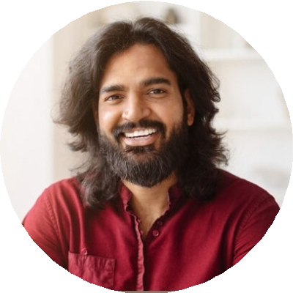
Education

Bachelor of Fine Arts in Photography School of Visual Arts, New York, NY | 2016

