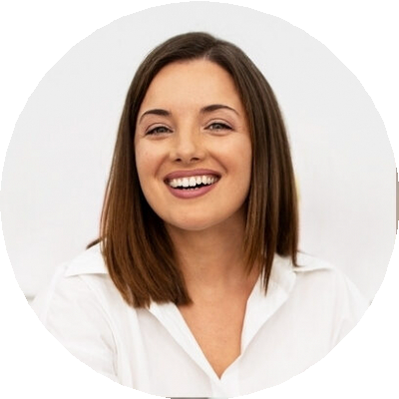
SAM WRIGHT
Bottling Line Operator
City, ST email@example.com
(123) 456-7890

Fast-paced Bottling Line Operator with attention to cleanliness and timing
Bottling operator with 7 years of experience on high-speed beverage lines. Helped increase line efficiency by 19% and maintained a 99.8% product quality compliance rate across 4 production lines.

Key Skills Bottling line setup
Capper/filler calibration Equipment sanitization GMP compliance
Line performance monitoring

Professional Experience
Bottling Line Operator Cascade Beverages | Seattle, WA | January 2019 - Present
Operate and monitor 4 bottling lines filling 60,000+ units daily
Increased line speed by 19% by adjusting machine synchronization
Maintained a 99.8% compliance rate across over 3 million bottles/year
Performed CIP (clean-in-place) sanitizations, reducing contamination risk by 100%

Education
High School Diploma
Packaging Operator NorthWest Bottlers | Seattle, WA | May 2016 - December 2018
Ran labeler and shrink-sleeve machines with 98.5% label accuracy Supported production switchovers, reducing line downtime by 22%

Roosevelt High School | 2015

