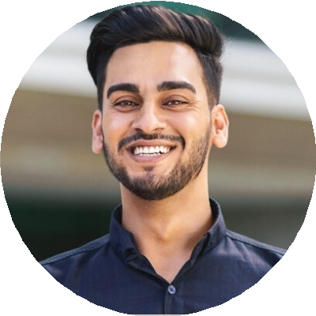
Professional Experience

Reese King
Medical Editor
City, State reesek@email.com
(123) 456-7890

Medical Editor
Clinovate Group, San Diego, CA | March 2018 - Present

Edited over 200 clinical trial documents and scientific articles for grammar, consistency, and clarity
Ensured compliance with FDA and EMA guidelines
Collaborated with medical writers to maintain accurate data presentation

Editorial Assistant
MedTek Publishing, San Diego, CA | May 2014 - February 2018
Proofread journal submissions and updated internal style guides Performed fact checking and terminology alignment for CME
materials

Education

LIM College | May 2016
Bachelor of Arts in Fashion Communication

Medical Editor committed to accuracy in clinical content
Medical Editor with 9 years of experience editing scientific and pharmaceutical content for journals and regulatory submissions. Expert in AMA style, data verification, and regulatory language.

Key Skills
Editorial styling Fashion writing
Photo shoot direction Trend research
Brand partnerships

