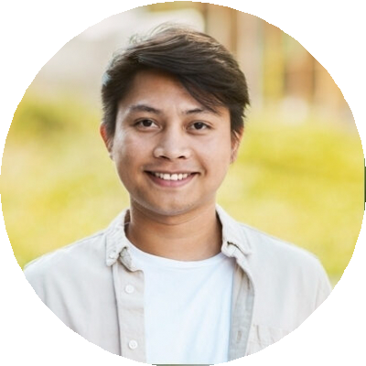
Blake Allen

Audio Editor

Chicago, IL blakea@email.com
(123) 456-7890

Experienced Audio Editor with a love for clean, immersive sound
Audio Editor with 7 years of experience editing podcasts, commercials, and voiceovers. Strong understanding of sound design, audio restoration, and mixing.

Key Skills
Adobe Audition Audio leveling
Noise reduction Dialogue editing
Multitrack mixing

Professional Experience
Audio Editor Creative Soundworks, Chicago, IL | March 2019 - Present
Edited over 500 podcast episodes, improving sound quality and listener retention Designed branded sound effects and music intros for corporate clients
Reduced post-production time by 20% through streamlined workflows

Audio Assistant MetroCast Studios, Chicago, IL | July 2016 - February 2019
Assisted in field recordings, equipment setup, and track editing Managed file exports and backups for multiple projects

Education
Bachelor of Science in Audio Production Columbia College Chicago | May 2016

