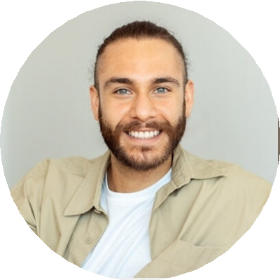
Professional Experience

Reese King
Portrait Photographer
City, ST email@example.com
(123) 456-7890
Portfolio

Portrait Photographer with 6 years of experience capturing professional headshots, family portraits, and senior sessions. Skilled in building client rapport, directing poses, and delivering polished digital galleries with consistent visual branding.

Portrait Photographer
RK Portraits, Austin, TX | January 2020 - Present
Photograph over 150 sessions annually, from senior portraits to corporate headshots
Develop packages and digital delivery systems to streamline client experience
Maintain lighting, studio setup, and camera gear for consistent image quality

Studio Photographer
Light & Lens, Austin, TX | August 2017 - December 2019

Worked in a fast-paced portrait studio, handling 6–10 sessions daily
Managed image culling, editing, and client selection appointments

Education

Bachelor of Arts in Photography
Texas State University, San Marcos, TX | 2017

Key Skills
Client communication High-volume editing
Natural lighting Posing direction
Professional headshots Studio portraiture

