Professional Experience

City, ST

Skyler Lewis

Fashion Photographer

September 2020 - Present

Fashion Photographer
StyleLine Magazine, New York, NY
Shot 60+ editorials and covers, working directly with creative directors and stylists
Developed visual mood boards and executed artistic vision from pre-production through retouching

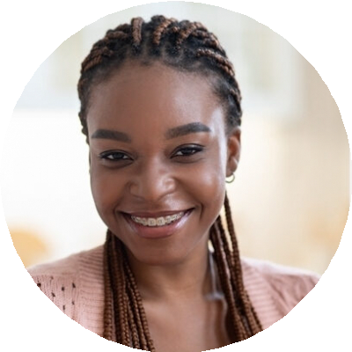
email@example.com
(123) 456-7890
Portfolio | LinkedIn

Fashion Photographer with 8 years of experience creating compelling editorial and lookbook imagery for print, runway, and digital platforms. Skilled in model direction,
on-location lighting, and post-production editing with a refined, trend-forward visual style.

Key Skills

Editorial photography Fashion styling collaboration High-end retouching
Model direction Portfolio development Studio lighting

Education
Freelance Fashion Photographer, Self- employed, New York, NY | May 2016 – August 2020
Produced lookbooks and model portfolios for designers and modeling agencies
Managed all client communications, contracts, and image delivery

Bachelor of Fine Arts in Photography
Parsons School of Design, New York, NY | 2016

