Reese King

Spa Receptionist
City, ST reese.king@email.com
(000) 000-0000

Calm and attentive Spa Receptionist with 3 years of experience delivering exceptional guest experiences in luxury wellness settings
Manages appointment flow, client service, and POS transactions with efficiency and grace. Adept at promoting spa services and managing a serene environment.

Key Skills

Spa scheduling software (MindBody, Zenoti) Upselling and service promotion
Front desk management Gift card and retail sales Daily cash handling Sanitation compliance

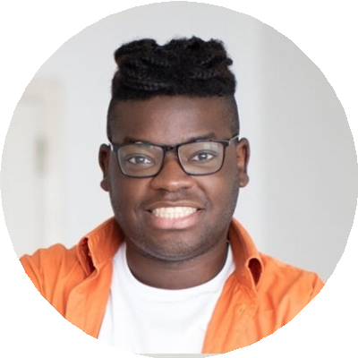

Professional Experience
January 2022 - Present Spa Receptionist Aura Wellness Spa, Tampa, FL
Schedule over 50 daily appointments and coordinate with 10 therapists
Promote packages and handle billing through Zenoti Maintain front lounge ambiance and cleanliness
October 2020 - December 2021 Receptionist Tranquility Spa, Tampa, FL
Managed check-ins and rescheduled bookings Trained in skincare product lines for upselling
Assisted in inventory restocking and POS systems

Education
High School Diploma Clearwater High School, Clearwater, FL | 2020

