DEVON YOUNG

Foley Artist
City, ST email@email.com
(123) 456-7890
Portfolio

Creative Sound Artist bringing texture and realism to every scene
Experienced Foley Artist with 6 years of experience creating and recording sound effects for feature films, animations, and video games. Skilled in capturing organic textures and syncing sound elements to visual cues.

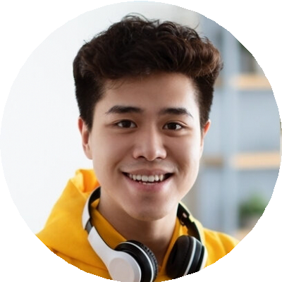
Key Skills
Ambient sound creation Foley recording
Layered sound design Mic placement
Sound synchronization Studio workflow

Education
Bachelor of Science in Audio for Visual Media
San Diego State University |
San Diego, CA | May 2017

Professional Experience
Foley Artist
EchoStage Audio, San Diego, CA | August 2019 - Present
Produced original sound elements for 10 feature films and 20+ animated shorts
Collaborated with post sound teams to match effects to performance and movement
Built sound libraries and maintained recording environments

Foley Assistant
SoundCube Studios, San Diego, CA | July 2017 - July 2019
Assisted senior Foley artists during live performance recordings
Sourced props and created DIY materials to match on- screen action
Edited and layered sounds for final mix prep

