BLAKE ALLEN
Computer Science Tutor
City, ST email@example.com
(123) 456-7890

Computer Science Major with a passion for peer education
CS Student with experience tutoring programming and supporting coding bootcamps. Comfortable with Python, Java, and helping peers develop logic skills. Interested in scholarships supporting STEM education access and mentorship.

Key Skills

     Code debugging
     Java
     Peer instruction
     Python
     Technical troubleshooting

Professional Experience

September 2023 -
Present
Peer Tutor Eastwood College Learning Center, Eastwood, NC
Tutored 30+ undergraduates in introductory Python and Java programming Created personalized study plans based on professor's syllabi and learning
needs

June 2023 -
August 2023

Education
Tech Camp Assistant CodeStart Bootcamp
Helped high school students build web apps during an 8-week summer coding program
Troubleshot code issues and assisted with final project demos

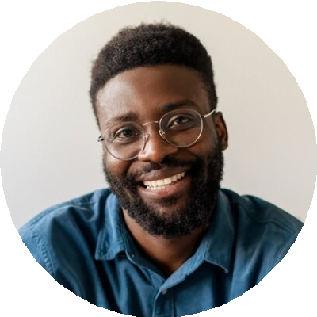

Bachelor of Science in Computer Science | Expected May 2027 Eastwood College, Eastwood, NC

