Chris Jackson

Dental Receptionist
City, ST
(000) 000-0000
email@example.com

Professional Experience

Dental Receptionist
BrightSmile Dental Group, Charlotte, NC April 2020 - Present
Managed a daily schedule of up to 80 patients across three dentists and two hygienists
Handled treatment estimates, billing questions, and patient payment plans
Maintained up-to-date patient records and coordinated referrals

Dental Ofce Coordinator
Gentle Family Dentistry, Charlotte, NC March 2016 - March 2020
Verified insurance benefits and filed electronic claims Reduced patient wait times by improving check-in workflow

Education

Certiicate in Dental Ofce Administration May
2016
Personable and highly organized dental receptionist with 7 years of experience in both private and multi-practice dental clinics.
Excels at handling insurance verification, appointment scheduling, and patient intake with attention to HIPAA compliance and front desk professionalism.

Key Skills
Dental insurance billing

Treatment plan coordination

EMR (Dentrix, Eaglesoft)

Check-in/check-out procedures

Appointment follow-ups

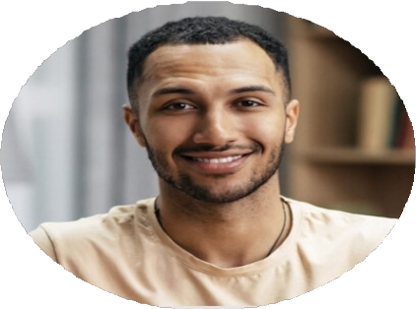
Carolina Healthcare Institute

