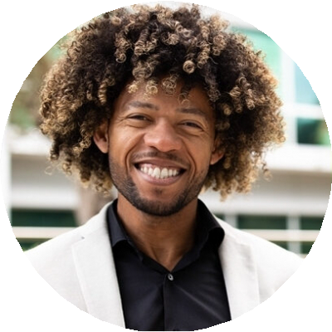

Reese King
Retail Pharmacist
City, ST email@example.com

Licensed retail pharmacist focused on patient safety and operational efficiency
Retail pharmacist with 9 years of experience providing prescription counseling, managing pharmacy staff, and ensuring regulatory compliance in high-volume pharmacy settings.

Professional Experience

Staf Pharmacist
CommunityCare Pharmacy, Columbus, OH | August 2018 - Present
Verified and dispensed up to 350 prescriptions per shift while maintaining accuracy standards
Provided patient consultations that improved medication adherence rates

Pharmacy Intern
CommunityCare Pharmacy, Columbus, OH | June 2014 - July 2018
Assisted with prescription processing and insurance verification during pharmacy school

Education
Doctor of Pharmacy (PharmD)
Ohio State University | 2018

Key Skills

Medication counseling

Pharmacy operations

Regulatory compliance

Inventory control

Patient education

