Professional Experience

Recruiting Specialist
Crimson Tech, San Diego, CA | October 2020 - Present
- Reduced average time-to-hire by 28% through pipeline optimization and hiring manager training
- Sourced candidates using LinkedIn Recruiter and job boards for 50+ open roles
- Created inclusive job descriptions, resulting in a 35% increase in diverse applicants

Recruiting Coordinator
PureWave Media, San Diego, CA | June 2017 - September 2020
- Managed interview scheduling and candidate tracking
- Built sourcing lists and conducted phone screens

HR Assistant
Seaside Financial, San Diego, CA | March 2016 - May 2017
- Maintained employee files and assisted with hiring events

Education

Bachelor of Science in Human Resource Development
San Diego State University | San Diego, CA | 2016

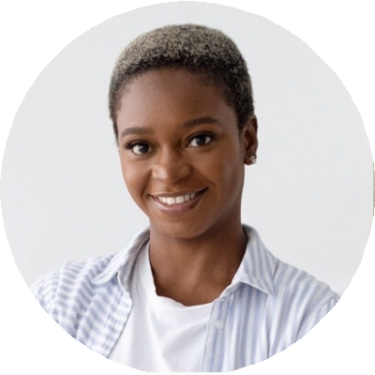
Recruiter focused on candidate experience and talent sourcing

Reese King
Recruiting Specialist
City, ST email@email.com
(123) 456-7890
resume-site.com
Strategic recruiting professional with 7 years of experience sourcing, screening, and interviewing candidates across tech and administrative roles.
Passionate about building inclusive pipelines, improving time-to-hire, and collaborating with hiring managers to align recruitment with business needs.

Key Skills
- Full-cycle recruiting
- Boolean search and sourcing
- Job description writing
- Candidate screening
- Diversity hiring

