Rachel Nguyen
DATA-DRIVEN PRODUCT MANAGER WITH EXPERIENCE IN AI AND MACHINE LEARNING
Strategic product manager with 10 years of experience leading large-scale artificial intelligence (AI)-powered product launches. Proven track record of increasing adoption rates, optimizing machine learning (ML) models, and driving innovation at scale.

Personal information

(555) 543-6789

rachel.nguyen@email.com LinkedIn | Portfolio Mountain View, CA

Key skills
AI/ML product strategy
Data-driven decision-making Growth hacking
Product roadmap execution
Stakeholder management

Professional experience
PRODUCT MANAGER | GOOGLE, MOUNTAIN VIEW, CA | AUGUST 2019 - PRESENT

Launched an AI-powered recommendation engine, increasing user engagement by 50%
Lead a cross-functional team of 25 engineers, designers, and data scientists
Implemented a data-driven roadmap, improving product adoption by 35%

SENIOR PRODUCT MANAGER | TECHCORP AI, SAN FRANCISCO, CA | JUNE 2015 - JULY 2019

Developed an NLP-powered chatbot, reducing customer support costs by 40%
Spearheaded a personalization initiative, driving a 20% increase in user retention

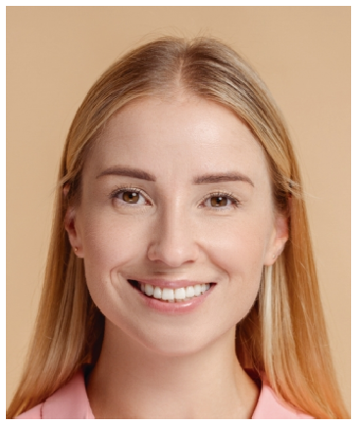





Education
MASTER OF SCIENCE IN ARTIFICIAL INTELLIGENCE | MASSACHUSETTS INSTITUTE OF TECHNOLOGY (MIT) | CAMBRIDGE, MA | AUGUST 2017

