Reese King
Portrait Photographer
Portrait Photographer with 6 years of experience capturing professional headshots, family portraits, and senior sessions. Skilled in building client rapport, directing poses, and delivering polished digital galleries with consistent visual branding.

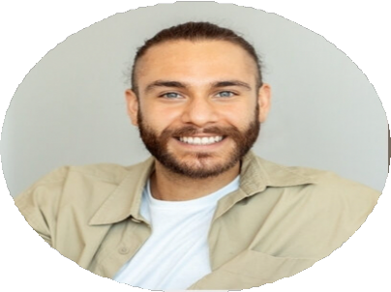





PERSONAL INFORMATION
(123) 456-7890

email@example.com Portfolio
City, ST

KEY SKILLS
Client communication High-volume editing Natural lighting Posing direction
Professional headshots Studio portraiture

PROFESSIONAL EXPERIENCE
January 2020 - Present

Portrait Photographer, RK Portraits, Austin, TX
- Photograph over 150 sessions annually, from senior portraits to corporate headshots
- Develop packages and digital delivery systems to streamline client experience
- Maintain lighting, studio setup, and camera gear for consistent image quality
August 2017 - December 2019

Studio Photographer, Light & Lens, Austin, TX
- Worked in a fast-paced portrait studio, handling 6–10 sessions daily
- Managed image culling, editing, and client selection appointments

EDUCATION

Bachelor of Arts in Photography
Texas State University, San Marcos, TX | 2017

