Stephanie
Reynolds
Customer-focused retail associate with a passion for sales
Friendly and energetic retail worker with strong communication and problem-solving skills. Dedicated to providing excellent customer service and driving sales growth.

Personal information

(555) 789-6543

stephanie.reynolds@email.com LinkedIn | Portfolio

Professional experience
SALES ASSOCIATE | TRENDY FASHION BOUTIQUE | JUNE 2022 - PRESENT

Assist an average of 50+ customers per shift, improving store efﬁciency
Increased customer satisfaction ratings by 15% through personalized service

Dallas, TX

Key skills
Point-of-sale (POS) systems and cash handling
Product recommendations and upselling
Customer engagement and problem resolution
Inventory restocking and merchandising
CASHIER & STOCK ASSOCIATE | LOCAL GROCERY STORE | MAY 2021 -
MAY 2022

Processed over $2,000 in daily transactions, maintaining accuracy and efﬁciency
Managed inventory and restocked products, ensuring an organized store layout

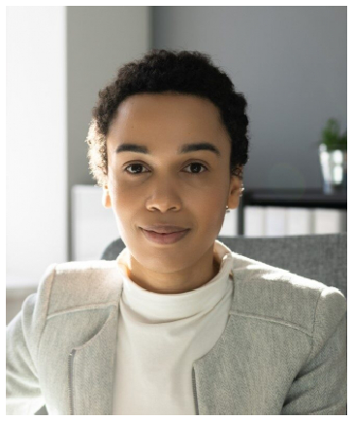





Education
HIGH SCHOOL DIPLOMA | LINCOLN HIGH SCHOOL, DALLAS, TX | APRIL 2021

