Reese King

Book Editor
Skilled Book Editor dedicated to enhancing storytelling
Book Editor with 10 years of experience in fiction and non-fiction publishing. Expert in developmental editing, manuscript assessments, and author collaboration.

Personal information

(123) 456-7890

reesek@email.com New York, NY

Professional experience
SENIOR BOOK EDITOR | BLUE WILLOW PRESS, NEW YORK, NY | JUNE 2018 - PRESENT

Edited 30+ published titles, including 5 award-winning novels
Provided developmental feedback that led to agent representation for several debut authors
Collaborated with marketing and design teams through launch

Key skills

Developmental editing Line editing Manuscript review Author collaboration Publishing contracts
EDITORIAL ASSISTANT | HUDSON & GREENE PUBLISHING, NEW YORK, NY | AUGUST 2014 - MAY 2018

Reviewed manuscripts, drafted editorial letters, and coordinated author edits
Managed author correspondence and tracked submissions

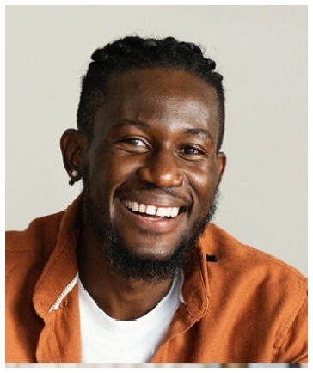



Education
BACHELOR OF ARTS IN LITERATURE
| NEW YORK UNIVERSITY | MAY 2014

