Chris Jackson

Event Social Media Manager

Event-focused social media pro connecting brands to audiences
Social media manager with 5 years of experience promoting corporate events, trade shows, and live conferences. Expert in live coverage, countdown campaigns, and branded hashtags.

Personal information

(123) 456-7890

email@email.com LinkedIn | Portfolio City, ST 98765

Key skills
Live event coverage Hashtag creation Vendor promotion Countdown campaigns Real-time posting
Post-event recap content

Professional experience
EVENT SOCIAL MEDIA MANAGER | PRISM EVENTS AGENCY, BOSTON, MA | MARCH 2021 - PRESENT

Managed social media presence for 20+ events annually, increasing ticket sales through Instagram campaigns
Launched event hashtags and real-time stories that boosted brand mentions by 300% Edited highlight reels and post-event galleries

SOCIAL MEDIA COORDINATOR | GATHERHUB, BOSTON, MA | MAY 2019 - FEBRUARY 2021

Supported corporate events through branded stories, countdowns, and vendor spotlight posts
Scheduled event promotion content to align with registration windows

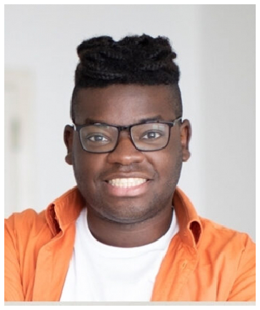




Education
BACHELOR OF ARTS IN MEDIA & EVENT COMMUNICATION | EMERSON COLLEGE, BOSTON, MA | MAY 2018

