Assisted sommeliers in curating wine pairings for tasting menus and fine dining guests
Maintained a meticulous bar setup, ensuring top-tier service for high-profile patrons


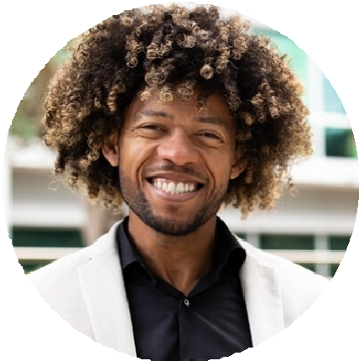



Luxury cocktail service Wine and spirit pairing Table-side mixology

Bachelor of Science in Hospitality & Culinary Arts
University of Chicago, IL | June 2014
Fine dining bartender with over nine years of experience crafting upscale cocktails and pairing wines in Michelin-starred restaurants. Specializes in sophisticated mixology, table-side cocktail preparation, and enhancing guest
dining experiences with curated beverage selections.
Senior Bartender, Le Château, Chicago, IL
June 2019 – Present

Created a refined cocktail program that increased wine and cocktail pairings by 35%
Provided table-side cocktail service, offering personalized recommendations for an elite clientele
Trained junior bartenders on proper glassware selection, spirit aging, and presentation techniques

Bartender, The Grand Table, Chicago, IL
August 2014 – June 2019

(321) 987-6540

benjamin.clark@example.com Chicago, IL
Guest relations in fine dining Premium ingredient sourcing

- Certified Sommelier (CMS Level 1), September 2018
- ServSafe Alcohol Certification, June 2014

