Vincent Romano
An accomplished fine dining server with five years of experience delivering excellent service in upscale Italian restaurants. A proven track record of exceeding sales targets and identifying creative ways to enhance the guest experience.

Professional experience
SERVER | LA TRATTORIA BELLA, PHILADELPHIA, PA | NOVEMBER 2022 - PRESENT

Personal information
(123) 456-7890

vincentromano@example.com LinkedIn | Portfolio
urpassed monthly sales goals by 25% through expert upselling techniques and personalized menu recommendations based on guest preferences and dietary restrictions.
Achieved monthly guest satisfaction scores of 91% to 94% by promptly addressing guest concerns and providing attentive, high-quality service.
Collaborate with kitchen and front-of-house staff to ensure seamless service during peak hours and special events.

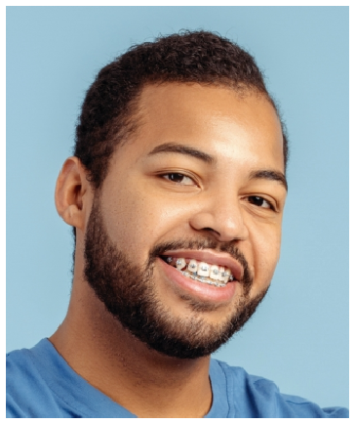




Philadelphia, PA 12345

Key skills
Guest relations
Upselling and sales techniques Communication
Customer service
Menu knowledge

Education
BACHELOR OF ARTS (B.A.) IN HOSPITALITY & TOURISM | TEMPLE UNIVERSITY, PHILADELPHIA, PA | JUNE 2018

SERVER | GIOVANNI’S RISTORANTE, PHILADELPHIA, PA | JULY 2018 - NOVEMBER 2022

Increased wine sales by 18% by offering expert wine pairing suggestions to enhance guests' dining experiences.
Exceeded monthly sales targets by 12% through in-depth knowledge of the menu, preparation techniques, and ingredient sourcing.
Delivered great guest service by anticipating needs and resolving concerns with patience and professionalism.

Certifications
ServSafe Certiﬁcation | June 2018

