David Thompson

Professor of Computer Science
Experienced computer science professor passionate about teaching and research in artificial intelligence and software engineering
Dedicated professor with over 10 years of experience teaching undergraduate and graduate courses in computer science. Researcher in AI, ML, and distributed computing. Published author with multiple peer-reviewed journal articles.

Personal Information
Professional Experience

(555) 567-8901

davidthompson@example.co m
PROFESSOR OF COMPUTER SCIENCE | MASSACHUSETTS INSTITUTE OF TECHNOLOGY (MIT), BOSTON, MA
AUGUST 2015 – PRESENT

Boston, MA

Education

Ph.D. in Computer Science Harvard University , May 2010
Master of Science in Computer Science

Harvard University, May 2006

Bachelor of Science in Computer Science

University of California, Berkeley , May 2004
- Design and deliver courses in AI, ML, and software engineering
- Lead research projects in AI, publishing ﬁndings in top-tier journals and conferences
- Supervise and mentor over 50 graduate students, guiding them through thesis and dissertation research

ASSISTANT PROFESSOR OF COMPUTER SCIENCE | BOSTON UNIVERSITY , BOSTON , MA
SEPTEMBER 2010 – JULY 2015
- Developed new coursework in software development and cloud computing
- Published 10+ peer-reviewed research papers in ML and distributed systems
- Secured over $500,000 in grant funding for computer science research initiatives




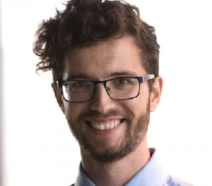
Key Skills

- Curriculum development and instructional design
- AI and ML
- Software engineering principles
- Research and academic publishing
- Student mentorship and academic advising

