Tyler Brooks
Sports Bar Bartender

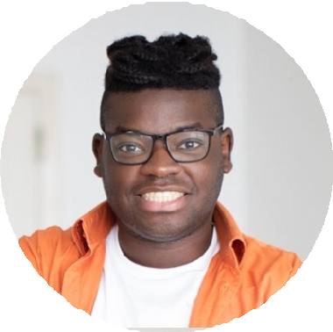





P E R S O N A L
I N F O R M AT I O N

(456) 321-9870

tyler.brooks@example.com LinkedIn
Chicago, IL

E D U C AT I O N
Associate Degree in Hospitality and Restaurant Management | University of Illinois, Chicago, IL | June 2018

K E Y S K I L L S
High-energy service Themed drink specials Crowd management Sports event bartending Upselling

A B O U T M E
Sports bar bartender with five years of experience in fast-paced, high-energy environments. Expert at handling large crowds, creating themed drink specials, and maintaining a fun, engaging atmosphere for patrons.

P R O F E S S I O N A L E X P E R I E N C E
BARTENDER | THE END ZONE SPORTS BAR, CHICAGO, IL
MARCH 2021 - PRESENT

Serve up to 300 guests per night, ensuring efficient drink service during major sporting events
Created a series of themed drink specials for game nights, increasing sales by 18%
Maintain bar inventory, reducing waste by 12% through improved stock management

BARTENDER | THE DUGOUT PUB, CHICAGO, IL
AUGUST 2018 - MARCH 2021

Provided quick and friendly service to sports fans, ensuring a fun and energetic atmosphere
Assisted in event planning for watch parties, increasing bar attendance on game nights

C E R T I F I C AT I O N S
BASSET ALCOHOL CERTIFICATION | JULY 2018

