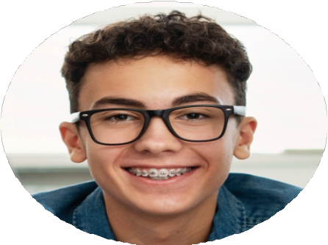
JEREMY BERGIN

ABOUT ME

PERSONAL INFORMATION
 (123) 456-7890
 jbergin@example.com  LinkedIn | Portfolio  San Diego, CA 12345

KEY SKILLS
Team management
Event management
Guest relations
Staff development
Hospitality management

CERTIFICATIONS
ServSafe Certiﬁcation, March 2019
A banquet server with five years of experience providing quality service to up to 200 attendees during large events. A strong history of collaborating with kitchen staff and banquet servers to refine operational workflows in fast-paced restaurant environments.

PROFESSIONAL EXPERIENCE
Lead Banquet Server
Harlem Banquet Hall, New York, NY | July 2021 - August 2024
Offer excellent service to guests across over 400 events with up to 200 attendees, coordinate restaurant operations, and ensure a memorable dining experience.
Manage and train a team of over 15 banquet servers and deﬁne workﬂows to maximize operational efﬁciency, contributing to a 92% guest satisfaction rating.
Resolve guest issues promptly and professionally, and coordinate with kitchen staff to accommodate unique dietary needs and menu adjustments.
Banquet Server
Rosemont Banquet Hall, New York, NY | June 2019 - July 2021
Delivered excellent guest service during over 100 events with up to 150 attendees, ﬁelded guest concerns, and identiﬁed timely solutions to ensure a quality dining experience, contributing to a 12% increase in repeat business.
Collaborated with diverse teams of banquet servers and chefs to reﬁne restaurant operations and enhance service delivery.

EDUCATION
Bachelor of Arts (B.A.) in Hospitality & Tourism
University of Syracuse, New York, NY | June 2019

