Yaling Zhang

A B O U T M E
A special education teacher with seven years of experience, specializing in education technology, behavior management, and data-driven instruction. A proven track record of incorporating adaptive technologies and social-emotional teaching strategies to support academic and personal growth in students with diverse learning needs.

P R O F E S S I O N A L E X P E R I E N C E

P E R S O N A L I N F O R M A T I O N
Special Education Teacher
Summit Valley Elementary, Denver, CO | August 2019 - Present

(123) 456-7890
email@example.com LinkedIn | Portfolio Denver, CO
- Design and implement IEPs for over 17 students per semester, resulting in an 85% goal attainment rate.
- Collaborate with interdisciplinary teams, occupational therapists, and speech pathologists to deliver holistic support in alignment with individual student
needs.
- To enhance student engagement, integrate multisensory learning strategies, such as interactive whiteboards, auditory learning support, and tactile learning
materials.

K E Y S K I L L S
Special Education Teacher
Eagle Ridge Middle School, Aurora, CO | September 2012 - June 2019

- IEPs
- Differentiated instruction
- Behavior intervention strategies
- Multisensory learning
- Inclusive classroom management
  - Delivered differentiated instruction to classes of 10 to 12 students with various disabilities, including autism spectrum disorder and ADHD.
  - Developed behavior intervention plans (BIPs) to address classroom challenges, resulting in an 18% increase in behavioral goal attainment.
  - Led professional development workshops for faculty on integrating inclusive teaching strategies into general education classrooms.

C E R T I F I C A T I O N S

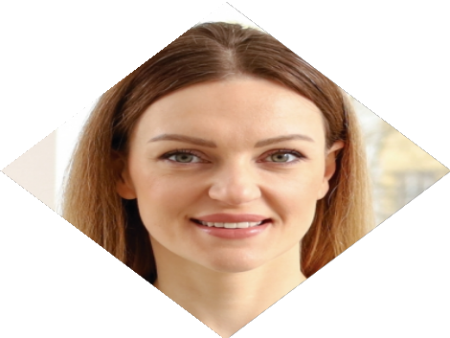




E D U C A T I O N
Bachelor of Science in Special Education

University of Colorado, Boulder, CO
March 2017
- State of Colorado Special Education Teaching Certification, May 2017
- Applied Behavior Analysis (ABA) Certification, August 2020

