Ryan Mitchell

Cybersecurity Data Scientist

Cybersecurity data scientist specializing in AI-powered threat detection
Experienced cybersecurity data scientist with seven years of experience in predictive analytics, risk management, and anomaly detection. Passionate about using AI to strengthen digital security.

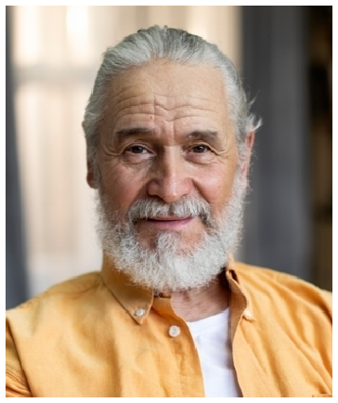





Personal information

(555) 432-7654

ryan.mitchell@email.com LinkedIn | Portfolio Washington, DC

Education
MASTER OF SCIENCE IN CYBERSECURITY ANALYTICS | JOHNS HOPKINS UNIVERSITY, BALTIMORE, MD | MAY 2016

Key skills
Threat intelligence and security analytics
Anomaly detection models Network intrusion detection
Machine learning for fraud prevention
Cloud security (AWS, Azure, GCP)

Professional experience
CYBERSECURITY DATA SCIENTIST | SECURENET SOLUTIONS | WASHINGTON, DC

| JUNE 2020 - PRESENT

Developed an AI-powered threat detection system that reduced security breaches by 40%
Implemented machine learning models to identify insider threats with 90% accuracy
Partnered with security teams to automate log analysis, cutting response times by 50%

DATA SCIENTIST (FRAUD DETECTION) | FINSEC TECHNOLOGIES | NEW YORK, NY

| JULY 2016 - MAY 2020

Built fraud detection algorithms that saved the company $5M annually
Designed an anomaly detection framework that improved transaction monitoring by 30%
Conducted risk modeling for financial cybersecurity compliance

