Rachel Adams

Event Bartender
Event bartender with six years of experience providing mobile bartending services for weddings, corporate events, and private parties. Skilled in setting up event bars, crafting specialty drinks, and ensuring smooth service at large-scale functions.

Personal information
(789) 123-6540

Professional experience
Lead Event Bartender | Elevate Events, Denver, CO July 2021 - Present

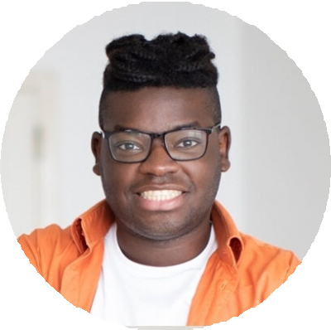




rachel.adams@example.com LinkedIn
Denver, CO

Education
Associate Degree in Event Management
Colorado State University, Denver,
CO | June 2017

Key skills
Mobile bar setup
Large event bartending Custom cocktail menu design Client relations
Staff supervision
Set up and operate mobile bars for high-profile events with up to 1,000 attendees
Work directly with clients to customize drink menus, leading to a 30% increase in specialty drink sales
Supervise a team of bartenders to ensure efficiency and guest satisfaction

Bartender | Peak Catering, Denver, CO May 2017 - July 2021
Provided beverage service at weddings, galas, and corporate events, maintaining a 98% customer satisfaction rating
Managed on-site inventory to ensure efficient service with minimal waste

Certifications
TIPS Alcohol Certification, May 2017

