Devon Young
Social Science Research Assistant





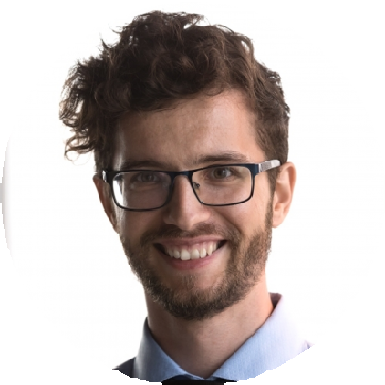

PERSONAL
INFORMATION
(555) 000-0000

email@example.com LinkedIn
City, ST

KEY SKILLS
Community-based research
Focus group coordination NVivo qualitative coding SPSS
Survey distribution and analysis

EDUCATION
Bachelor of Arts in Sociology University of Minnesota, Minneapolis, MN | May
2018

ABOUT ME

Social Science Researcher with experience in qualitative and quantitative methods
Organized Research Assistant with 5 years of experience supporting sociology and education research projects.
Proficient in survey design, data collection, and focus group moderation. Adept at SPSS, NVivo, and presenting findings to diverse audiences.

PROFESSIONAL EXPERIENCE
SOCIAL SCIENCE RESEARCH ASSISTANT | DEPARTMENT OF SOCIOLOGY, UNIVERSITY OF MINNESOTA
MAY 2020 - PRESENT
Coordinate three studies on educational inequality and youth development
Develop and analyze online surveys reaching over 800 participants
Conduct qualitative coding in NVivo and compile thematic reports

PROGRAM EVALUATION INTERN | TWIN CITIES YOUTH PROJECT
APRIL 2018 - APRIL 2020
Facilitated 12 focus groups and collected feedback on program effectiveness
Cleaned and organized survey data to support funding reports
Created visual summaries of key trends for community stakeholders

