Shawn White

Talent Acquisition Coordinator
Talent acquisition professional focused on high-volume recruiting and process improvement
Resourceful HR coordinator with 5 years of experience supporting recruitment operations, interview scheduling, and ATS. Known for streamlining hiring pipelines and improving candidate communication in fast-paced environments. Brings a balance of administrative strength and people-first strategy.

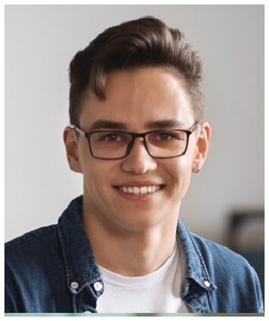




PERSONAL INFORMATION
(123) 456-7890
email@email.com resume-site.com City, ST

KEY SKILLS
ATS
Calendar coordination
Candidate communications
Job posting management
Recruitment process support

EDUCATION
BACHELOR OF ARTS IN PSYCHOLOGY | UNIVERSITY OF COLORADO | BOULDER, CO | 2019

PROFESSIONAL EXPERIENCE
TALENT ACQUISITION COORDINATOR | LEXAR HEALTH SOLUTIONS, DENVER, CO | APRIL 2021 - PRESENT
Manage interview scheduling for six recruiters, averaging 40+ interviews per week
Maintain applicant data in Greenhouse ATS with 99% accuracy
Created candidate email templates that improved response rates by 30%

HR ASSISTANT | REDRIVER LOGISTICS, DENVER, CO | JULY 2019 - MARCH 2021
Posted job openings and screened resumes for hiring managers
Prepared onboarding documents and tracked offer acceptances
Delivered weekly reports on time-to-fill metrics

