Mark Sullivan

Dive Bar Bartender

Dive bar bartender with seven years of experience in laid-back, neighborhood bars. Known for fostering a welcoming atmosphere, serving classic cocktails, and building relationships with regular patrons.

Personal information

(654) 789-3210

mark.sullivan@example.co m
 LinkedIn Nashville, TN

Key skills

Fast-paced drink preparation
Customer relationship building
Classic cocktails and beer knowledge
Dive bar atmosphere creation
Live music and event coordination

Professional Experience
BARTENDER | THE RUSTY TAP, NASHVILLE, TN MAY 2020 - PRESENT
Provide fast-paced service to a loyal customer base, serving classic and craft cocktails
Manage bar operations, including stocking, cleaning, and ensuring a friendly atmosphere
Organize live music nights and themed events to increase weekly foot traffic

BARTENDER | THE BARREL ROOM, NASHVILLE, TN AUGUST 2016 - MAY 2020
Built relationships with patrons, contributing to a 20% increase in returning customers
Assisted in cost-saving inventory management, reducing liquor waste by 15%

Education
Associate Degree in Business & Hospitality University of Tennessee, Nashville, TN | June 2016

Certifications

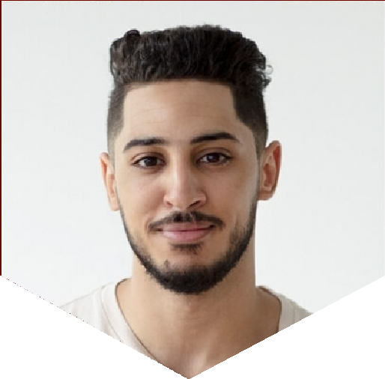

TABC Alcohol Certification | July 2016

