Reese King

Spa Receptionist
Calm and attentive Spa Receptionist with 3 years of experience delivering exceptional guest experiences in luxury wellness settings
Manages appointment flow, client service, and POS transactions with efficiency
and grace. Adept at promoting spa services and managing a serene environment.

PERSONAL INFORMATION

(000) 000-0000
PROFESSIONAL EXPERIENCE
SPA RECEPTIONIST | AURA WELLNESS SPA, TAMPA, FL JANUARY 2022 – PRESENT

reese.king@email.com City, ST
- Schedule over 50 daily appointments and coordinate with 10 therapists
- Promote packages and handle billing through Zenoti
- Maintain front lounge ambiance and cleanliness

KEY SKILLS
RECEPTIONIST | TRANQUILITY SPA, TAMPA, FL OCTOBER 2020 – DECEMBER 2021

- Spa scheduling software (MindBody, Zenoti)
- Upselling and service promotion
- Managed check-ins and rescheduled bookings
- Trained in skincare product lines for upselling
- Assisted in inventory restocking and POS systems

- Front desk management
EDUCATION




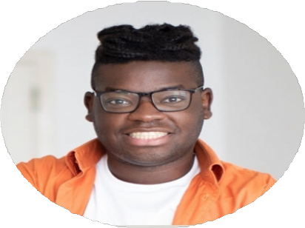
- Gift card and retail sales
- Daily cash handling
- Sanitation compliance
- High School Diploma, Clearwater High School, Clearwater, FL | 2020 |

