Emma Carson

Entry-Level Dental Hygienist

Compassionate and detail-oriented dental hygienist with a strong educational background in oral health and patient care. Skilled in conducting dental cleanings, taking X-rays, and educating patients on proper oral hygiene practices. Committed to providing excellent care and ensuring patient comfort.

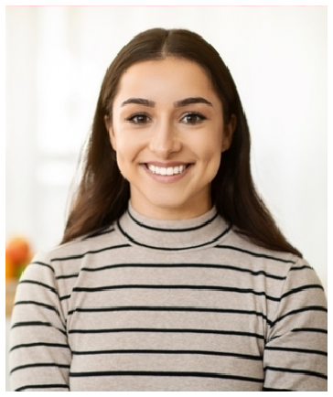




Personal information

(123) 456-7890

emma@example.com New York, NY
Education
ASSOCIATE OF SCIENCE IN DENTAL HYGIENE | NEW YORK UNIVERSITY COLLEGE OF DENTISTRY | NEW YORK, NY | MAY 2024

Key skills
Dental cleanings and prophylaxis Digital radiography
Fluoride application Patient education Infection control Instrument sterilization
Professional experience
DENTAL HYGIENIST EXTERN | BRIGHT SMILES DENTAL CLINIC | NEW YORK, NY | JANUARY 2024 - MAY 2024

Performed dental cleanings and fluoride treatments for 20+ patients per day Educated patients on proper oral hygiene and preventive care
Assisted dentists with procedures and maintained sterilization protocols

DENTAL ASSISTANT (INTERNSHIP) | HEALTHY SMILES DENTAL | BROOKLYN, NY | JUNE 2023 - DECEMBER 2023
Assisted with chairside procedures and patient preparation Took digital X-rays and maintained accurate records
Ensured compliance with OSHA and infection control standards

Certifications
Registered Dental Hygienist (RDH) – May 2024
CPR & First Aid Certified – American Red Cross | April 2024

