Blake Allen

Computer Science Tutor

Computer Science Major with a passion for peer education
CS Student with experience tutoring programming and supporting coding bootcamps. Comfortable with Python, Java, and helping peers develop logic skills. Interested in scholarships supporting STEM education access and mentorship.

Personal information
(123) 456-7890

Professional experience
Peer Tutor | Eastwood College Learning Center, Eastwood, NC September 2023 - Present

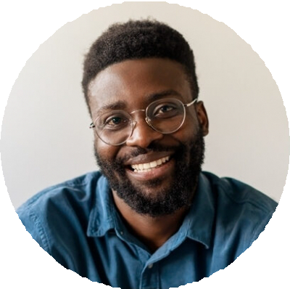



email@example.com City, ST

Key skills
Code debugging Java
Peer instruction
Python
Technical troubleshooting

Education
Bachelor of Science in Computer Science | Expected May 2027 Eastwood College, Eastwood, NC
Tutored 30+ undergraduates in introductory Python and Java programming
Created personalized study plans based on professor's syllabi and learning needs

Tech Camp Assistant | CodeStart Bootcamp June 2023 - August 2023
Helped high school students build web apps during an 8-week summer coding program
Troubleshot code issues and assisted with final project demos

