Reese King

Educational Videographer

Educational Videographer committed to accessible learning content
Video Producer with 10 years of experience developing instructional videos, e-learning modules, and academic media for K–12 and university settings. Expert in visual storytelling that supports curriculum goals and improves knowledge retention.

Contact information
Professional experience
SENIOR EDUCATIONAL VIDEOGRAPHER | MIDWEST LEARNING CONSORTIUM, MINNEAPOLIS, MN | AUGUST 2017 - PRESENT

(000) 000-0000

email@email.com Portfolio
City, ST

Key skills
Camera Scripting for Education Closed Captioning
Educational Content Editing
Learning Management Systems (LMS)
Lighting and Studio Setup Lecture Capture Screencasting
Video Archiving
Produced over 500 educational video modules for use in hybrid and online courses
Collaborated with curriculum developers and subject matter experts to script visual lessons
Implemented closed captioning standards and ADA-compliant video practices

MEDIA SPECIALIST | NORTH CENTRAL UNIVERSITY, MINNEAPOLIS, MN | JUNE 2013 - JULY 2017

Filmed and edited classroom lectures and tutorial videos for digital learning
Managed media library of over 1,000 instructional clips

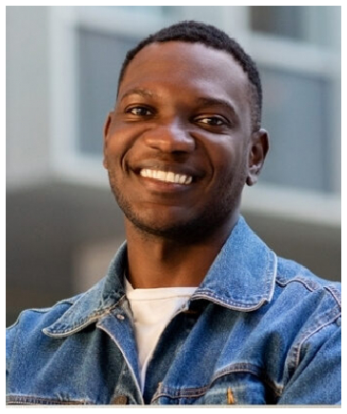





Education
BACHELOR OF SCIENCE IN EDUCATIONAL MEDIA | 2013 | MINNESOTA STATE UNIVERSITY, MANKATO, MN

