Reese King

Criminal Investigator

P E R S O N A L I N F O R M AT I O N

(000) 000-0000

reese.king@email.com LinkedIn URL
Detroit, MI 48201

E D U C AT I O N

Bachelor of Science (B.S.) in Criminal Justice
Wayne State University | Detroit, MI May 2011

A B O U T M E
Criminal investigator with 11 years of experience conducting felony investigations, collecting evidence, and preparing cases for prosecution. Proven ability to close complex cases involving robbery, assault, and organized crime through fieldwork and interagency collaboration.

P R O F E S S I O N A L E X P E R I E N C E
Criminal Investigator | March 2015 - Present
Detroit Police Department | Detroit, MI
Investigate 100+ felony cases per year, maintaining a 72% case clearance rate across major crimes
Interview witnesses and suspects, prepare affidavits, and collaborate with district attorneys to support trial success
Supervise crime scene processing teams and coordinate with lab personnel for evidence verification
Detective | June 2011 - February 2015
Wayne County Sheriff's Office | Detroit, MI
Conducted targeted investigations in narcotics and theft units, leading to 38 major arrests
Used surveillance, informants, and digital data recovery to build strong case evidence
Trained junior officers in report writing and courtroom preparation

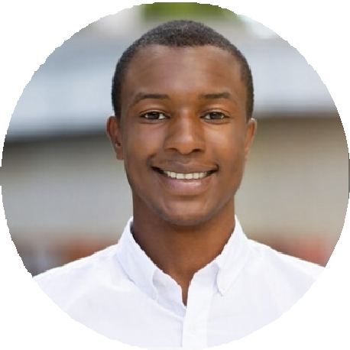





C E R T I F I C AT I O N S
Michigan Criminal Investigator Certification | MCOLES | 2015 Interview and Interrogation Certification | Reid Technique | 2017

