Reese King

Freelance Social Media Content Writer
Freelance Social Media Content Writer with 7 years of experience creating engaging, brand-consistent posts for multiple platforms. Skilled in campaign planning, hashtag strategy, and multimedia integration. Known for driving follower growth and increasing engagement rates.

PERSONAL INFORMATION
PROFESSIONAL EXPERIENCE
FREELANCE SOCIAL MEDIA CONTENT WRITER | SELF-EMPLOYED | REMOTE MAY 2016 – PRESENT

(000) 000-0000

reese.king@email.com LinkedIn
City, ST
- Produced social content calendars and copy for Instagram, LinkedIn, and TikTok, increasing client follower counts by an average of 45%
- Designed and tested captions, hashtags, and calls-to-action that improved post engagement by up to 30%
- Partnered with graphic designers and videographers to create coordinated multimedia campaigns, boosting reach by 25%

KEY SKILLS
SOCIAL MEDIA ASSISTANT | BRIGHTVIEW DIGITAL | ORLANDO, FL JUNE 2014 – MAY 2016

- Campaign Planning
- Content Scheduling
- Engagement Optimization
- Hashtag Research
- Scheduled and optimized social posts for client accounts, increasing content impressions by 18%
- Monitored analytics to track post performance and refine strategy based on audience behavior
- Assisted in influencer outreach campaigns, resulting in a 12% increase in brand mentions

- Multimedia Collaboration
- Social Analytics

EDUCATION




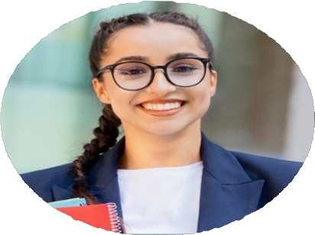
  - Bachelor of Arts in Marketing, University of Central Florida | Orlando, FL | May 2014

CERTIFICATIONS
  - Social Media Marketing Professional Certificate | Meta | April 2022

