Maria Lopez
Experienced CNA instructor with 10 years of expertise in training and mentoring future CNAs. Adept at curriculum development, clinical instruction, and preparing students for state certification exams. Passionate about fostering the next generation of skilled health care professionals.

PERSONAL INFORMATION
(123) 456-7890

email@example.com LinkedIn | Portfolio Los Angeles, CA

KEY SKILLS
Clinical instruction Curriculum development Student mentorship Patient care training
Certiﬁcation exam preparation

PROFESSIONAL EXPERIENCE
September 2016 - Present
CNA Instructor, California Health Training Institute | Los Angeles, CA
- Develop and deliver comprehensive CNA training programs, leading to a 95% student certification pass rate.
- Conduct hands-on clinical instruction in long-term care facilities, ensuring students gain practical experience in patient care.
- Mentor and evaluate student performance, providing feedback to improve technical skills and patient interactions.
June 2012 - August 2016
Certified Nursing Assistant, St. Mary's Hospital | Los Angeles, CA
- Provided bedside care for patients in a 250-bed hospital and supported physicians in treatment procedures.
- Trained new CNAs on hospital procedures, improving overall efficiency and patient care standards.

EDUCATION

Bachelor of Science (B.S.) in Nursing
University of California, Los Angeles, CA | May 2012

CERTIFICATIONS

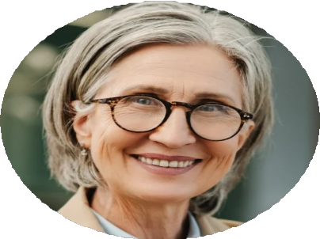




  - Certified Nursing Assistant (CNA), State of California, June 2012
  - Certified Nurse Educator (CNE), American Nurses Credentialing Center (ANCC), August 2016

