Personal information

(123) 456-7890

Raheem
Richardson

Entry-Level Bartender
Certified bartender with over three years of experience in the hospitality industry, increasing guest satisfaction scores by 15% through exceptional customer service, guest relations, and innovative mixology techniques. Identified creative solutions to improve the guest experience, leading to a 20% increase in repeat business and a 10% boost in upselling premium beverages.

email@example.com LinkedIn | Portfolio Seattle, WA

Education
Bachelor of Arts (B.A.) in Hospitality & Tourism

University of Washington, Seattle, WA | June 2021

Key skills
Mixology Guest relations
Communication Inventory management Upselling techniques

Professional experience

Bartender | Starlight Pub, Seattle, WA August 2023 - Present

Deliver exceptional service to over 100 patrons per day, coordinate bar operations, and maintain a 91% satisfaction rating
Upsell specialty drinks and menu items, building positive relationships with patrons to generate repeat business
Conduct forecasting and restocking for bar inventory and ensure strict adherence to sanitation standards

Server | Starlight Pub, Seattle, WA July 2021 - August 2023

Provided outstanding service to over 100 guests per shift and coordinated effectively with kitchen staff, bartenders, and hostesses during high-volume periods
Educated patrons on menu items and daily specials, utilizing upselling techniques to exceed monthly sales goals by 20% and 30%

Certifications





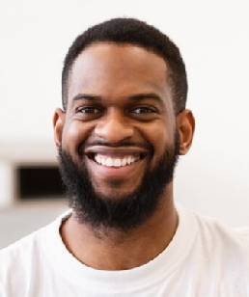
ServSafe Certification | June 2021

