Blake Allen
Photographer Assistant

Personal

INFORMATION
Photography Assistant with 3 years of experience supporting portrait, commercial, and event photographers in studio and on-location shoots. Skilled in lighting setup, camera maintenance, and managing smooth shoot logistics.

Professional Experience
PHOTOGRAPHER ASSISTANT | LIGHTCRAFT STUDIOS, MIAMI, FL JULY 2022 - PRESENT

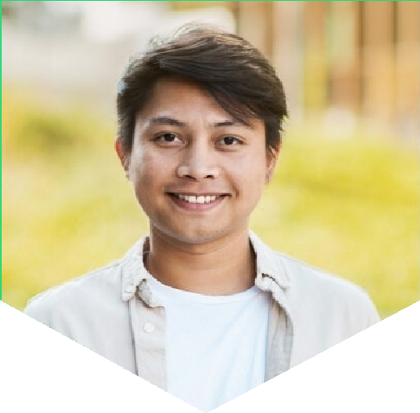

(123) 456-7890

 email@example.com Portfolio
City, ST

Key skills

Assistant camera operation Equipment setup
Light meter usage
Reflector handling Set management Studio organization
Set up and maintained lighting and backdrop systems for 100+ professional shoots
Assisted with image selection and backup management post-shoot Coordinated equipment packing and transport to on-location jobs
STUDIO INTERN | BRIGHTFRAME PHOTOGRAPHY, MIAMI, FL MAY 2021 - JUNE 2022
Supported team on client sessions and ensured equipment was prepped and cleaned between shoots
Shadowed lead photographers and took behind-the-scenes documentation

Education
Associate of Arts in Photography Miami Dade College, Miami, FL | 2021

