Laura Williams
A committed teacher aide with 3 years of experience supporting classroom teachers in providing educational assistance to students. Skilled in classroom management, one-on-one support, and contributing to a positive learning environment. Adept at helping students with special needs succeed through differentiated instruction and compassionate support.

Personal information

(123) 456-7890

email@example.com LinkedIn | Portfolio

Professional experience
TEACHER AIDE | RIVERWOOD HIGH SCHOOL, ATLANTA, GA | JANUARY 2020 - PRESENT

Provided individual support for students with learning disabilities, improving their participation and performance by 20%.
Assisted in the preparation of teaching materials and resources, ensuring the classroom environment was organized and conducive to learning.
Coordinated and led small group activities, focusing on enhancing students' reading and writing skills.

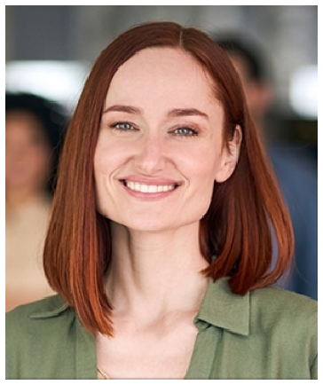




City, ST

Education
ASSOCIATE OF SCIENCE IN EARLY CHILDHOOD EDUCATION | GEORGIA STATE UNIVERSITY | 2018

Key skills

Classroom management Differentiated instruction Student support Organizational skills Communication

TEACHER AIDE | WOODLAND MIDDLE SCHOOL, ATLANTA, GA | SEPTEMBER 2018 - JUNE 2020

Worked with students in classrooms, providing additional instruction and support during lessons and assignments.
Assisted in maintaining classroom discipline and creating a structured environment for students to learn.
Supported students during extracurricular activities and ﬁeld trips, ensuring their safety and active participation.

Certifications
CPR and First Aid Certiﬁed | 2019

