Kevin Dorsey

Chairside Dental Assistant
Chairside dental assistant with strong clinical preparation and workflow coordination
Experienced assistant with 5 years of hands-on support for general and cosmetic
procedures. Efficient in preparing materials, organizing dental tools, and assisting chairside with a focus on patient comfort and procedural flow.

PERSONAL INFORMATION

(000) 000-0000
PROFESSIONAL EXPERIENCE
CHAIRSIDE DENTAL ASSISTANT | LAKESIDE DENTAL, ST. LOUIS, MO JANUARY 2021 – PRESENT

kevin.dorsey@email.com St. Louis, MO
- Assisted in 10+ procedures daily, including crowns, root canals, and fillings
- Anticipated dentist needs to reduce treatment time by 20%
- Maintained sterilization logs and ensured operatory readiness

KEY SKILLS
DENTAL ASSISTANT | URBAN DENTAL CENTER, ST. LOUIS, MO JUNE 2019 – DECEMBER 2020

- Chairside support
- Composite and amalgam prep
- Dental suction operation
- Set up trays, maintained infection control standards, and documented treatments
- Supported cosmetic procedures such as whitening and veneer placements

- Intraoral photography
EDUCATION




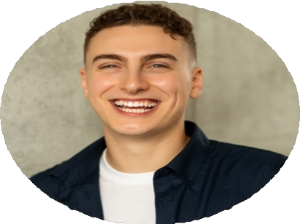
- Patient positioning
- Diploma in Dental Assisting, Missouri Dental Institute, St. Louis, MO | May 2019
|

