Skyler Lewis

Fry Cook

Hardworking Fry Cook focused on quality and speed
Experienced Fry Cook with 6 years in casual dining and fast food kitchens. Known for precise timing, safe oil handling, and consistent food presentation. Familiar with fryer cleaning, temperature checks, and batch cooking for lunch and dinner rushes.

PERSONAL INFORMATION
PROFESSIONAL EXPERIENCE
FRY COOK | BIG CATCH SEAFOOD & GRILL, ORLANDO, FL AUGUST 2020 – PRESENT

000-000-0000

email@email.com City, ST

KEY SKILLS
- Handle all fryer operations during lunch and dinner, averaging 120+ orders per shift
- Maintain crispness and appearance of fried foods with consistent oil rotation
- Prepare breaded items ahead of service for efficiency
- Trained 2 new hires on fryer timing and safe cleanup procedures

  - Batch frying
LINE COOK | CRAVE STREET EATS, ORLANDO, FL MAY 2017 – JULY 2020

  - Cleaning and oil filtering
  - Deep fryer safety
  - Fast food prep
  - Food portioning
  - Operated fryer, grill, and cold stations on rotating shifts
  - Prepped seafood and frozen items according to health and safety standards
  - Performed daily fryer maintenance and deep cleaning duties

  - Fryer temperature
control

EDUCATION




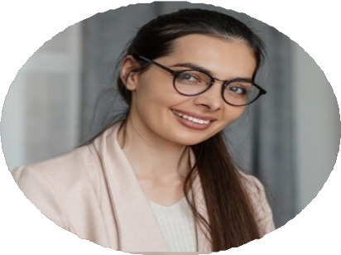
  - Lunch and dinner rush service
  - Safe food handling
  - High School Diploma, Lakeview High School, Orlando, FL | 2016 |

