Avery Harris

Content Marketing Strategist
Creative Content Strategist with 7 years of experience developing SEO-driven content and storytelling campaigns that grow brand visibility and lead generation
Expert in editorial planning, content SEO, and B2B thought leadership campaigns.

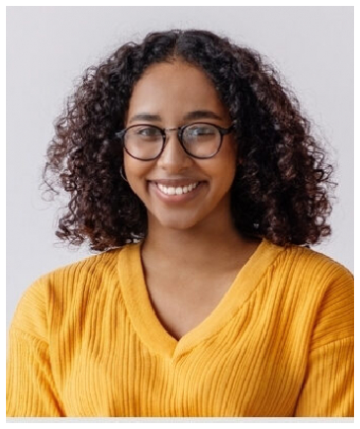




Personal information

(000) 000-0000

email@email.com San Diego, CA

Key skills
Content strategy Editorial calendars SEO writing
Blogging and lead magnets
Keyword mapping

Education
BACHELOR OF ARTS IN COMMUNICATIONS | SAN DIEGO STATE UNIVERSITY | 2016

Professional experience
CONTENT MARKETING STRATEGIST | FLOWGRID, SAN DIEGO, CA | FEBRUARY 2020 - PRESENT

Developed a content strategy that increased organic leads by 48% in one year
Published 60+ blog posts aligned with top-funnel keywords and buyer personas
Collaborated with design to produce lead magnets downloaded over 5,000 times

CONTENT COORDINATOR | SWIFTREACH MARKETING, SAN DIEGO, CA | AUGUST 2016 - JANUARY 2020

Maintained editorial calendar and tracked KPIs using HubSpot
Rewrote underperforming content, increasing blog engagement by 35%
Assisted with pillar page development for SEO clusters

