
Campus Ambassador
Campus Ambassador with three years of experience representing university programs at events and on social media. Skilled at generating leads, organizing campus tours, and creating promotional content.
PROFESSIONAL EXPERIENCE

P E R S O N A L
I N F O R M A T I O N

(323) 555-4422

taylornguyen@example.com LinkedIn | Portfolio
EDUCATION
September 2020 - Present
Campus Ambassador | UCLA Admissions, Los Angeles, CA

Conducted 30+ campus tours per semester, correlating with a 10% increase in applications.
Produced video testimonials that garnered 5,000+ views online.

June 2019 - August 2020
Student Presenter | Transfer Student Orientation, UCLA

Delivered presentations to 200+ attendees, achieving a 95% satisfaction rate. Managed Q&A panels, improving information retention by 20%.

Los Angeles, CA

K E Y S K I L L S
B.A. in Communications UCLA | May 2024 |





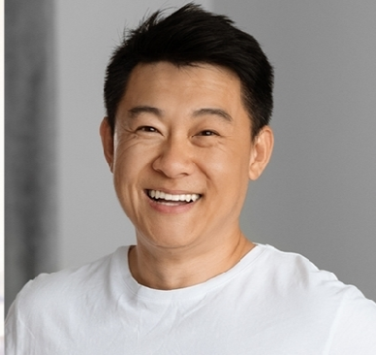
Campus Tours Content Creation Public Presentation Lead Generation

