Logan Hall
Paid Social Media Specialist

A B O U T M E

P E R S O N A L I N F O R M A T I O N
Paid Social Media Specialist with five years of experience creating and optimizing advertising campaigns across Facebook, Instagram, and TikTok. Skilled in budget management, audience segmentation, and ad creative strategy. Known for reducing acquisition costs while scaling performance.





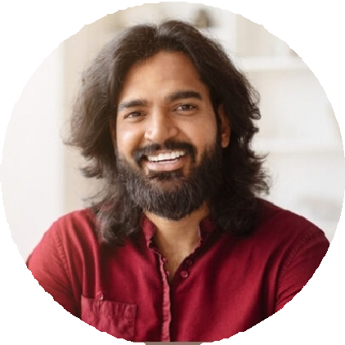
(000) 000-0000

logan.hall@email.com

LinkedIn | Portfolio

Boston, MA 02116

E D U C A T I O N

Bachelor of Science (B.S.) in Marketing
Northeastern University, Boston, MA | May 2018

K E Y S K I L L S

Ad creative testing Budget optimization Conversion tracking Facebook Ads Manager ROAS strategy
P R O F E S S I O N A L E X P E R I E N C E

PAID SOCIAL MEDIA SPECIALIST | BREEZETECH RETAIL, BOSTON, MA
JANUARY 2021 - PRESENT

Launched performance campaigns with $800K annual budget, delivering a 3.4x ROAS across Meta platforms
Reduced cost per lead by 26% by testing new audience sets and creative variants
Partnered with design and copy teams to create assets that improved click-through rates by 33%

DIGITAL AD COORDINATOR | EASTWOOD LABS, CAMBRIDGE, MA
JUNE 2018 - DECEMBER 2020

Managed daily Facebook Ads campaigns and tracked performance through Meta Business Manager
Created A/B testing frameworks that informed future bidding and creative decisions
Reported ad results to the marketing director, helping shape quarterly acquisition strategies

C E R T I F I C A T I O N S

Meta Certified Media Buying Professional | 2022 Google Ads Search Certification | 2021

