Shawn White
Grill Cook
Grill Cook with six years of experience preparing steaks, burgers, and specialty grilled dishes in casual and fine dining settings. Recognized for consistent food quality and ability to stay calm under pressure.
PROFESSIONAL EXPERIENCE

P E R S O N A L I N F O R M A T I O N

(123) 456-7890

email@example.com LinkedIn
City, ST
June 2020 - Present
Grill Cook | Blue Ridge Steakhouse, Denver, CO

Prepare and plate over 300 grilled items daily, maintaining consistent doneness and presentation
Implemented a new cleaning schedule that helped prevent health violations Assisted with new seasonal menu rollout focused on regional grilled specialties
July 2017 - May 2020
Line Cook | Miller's Roadhouse, Boulder, CO

Operated grill and fry stations during lunch and dinner service
Trained two junior staff members, helping them pass internal skills tests

EDUCATION





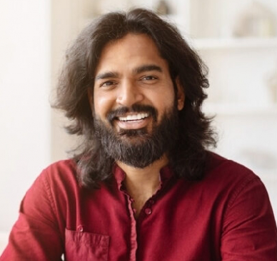
K E Y S K I L L S

Broiling and grilling Food safety compliance
Meat temperature control
Portion control Recipe adaptation Station management Temperature control Time management
Diploma in Culinary Techniques
Mountain View Culinary School | 2017 |

