Elizabeth Thoms

A B O U T M E
Luxury sales consultant with expertise in high-end retail and personalized client service
Experienced luxury retail professional with nine years of experience in high-end fashion, jewelry, and luxury goods sales.

P R O F E S S I O N A L E X P E R I E N C E

P E R S O N A L I N F O R M A T I O N
Luxury Sales Consultant
Prestige Boutique, Beverly Hills, CA | April 2019 - Present

(555) 456-7890
elizabeth.t@email.com LinkedIn | Portfolio
- Increased luxury sales revenue by 40% by cultivating long-term client relationships
- Provided personalized shopping experiences, leading to a 30% increase in repeat customers
- Develop exclusive VIP events, attracting high-profile clientele

Beverly Hills, CA
Senior Sales Associate
High-End Fashion Co., Los Angeles, CA | June 2015 - March 2019

K E Y S K I L L S
- Managed a portfolio of top-tier clients, ensuring brand loyalty and premium service

  - Luxury product expertise (watches, fashion, jewelry)
  - High-net-worth client relationship management
  - Personalized shopping experiences
  - Sales strategy and merchandising
  - Exceeded monthly sales goals by 20%, ranking among the top three consultants

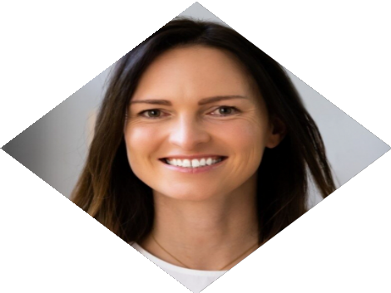





E D U C A T I O N
Associate Degree in Fashion Merchandising

Los Angeles College of Fashion May 2015

