Skyler Lewis
Fashion Photographer

A B O U T M E

P E R S O N A L
I N F O R M AT I O N
Fashion Photographer with 8 years of experience creating compelling editorial and lookbook imagery for print, runway, and digital platforms. Skilled in model direction, on-location lighting, and post-production editing with a refined, trend-forward visual style.

(123) 456-7890

email@example.com Portfolio | LinkedIn City, ST
K E Y S K I L L S
Editorial photography Fashion styling collaboration High-end retouching
Model direction Portfolio development Studio lighting
P R O F E S S I O N A L E X P E R I E N C E
FASHION PHOTOGRAPHER | STYLELINE MAGAZINE, NEW YORK, NY
SEPTEMBER 2020 - PRESENT

Shot 60+ editorials and covers, working directly with creative directors and stylists
Developed visual mood boards and executed artistic vision from pre-production through retouching
Freelance Fashion Photographer, Self-employed, New York, NY | May 2016 – August 2020
Produced lookbooks and model portfolios for designers and modeling agencies
Managed all client communications, contracts, and image delivery





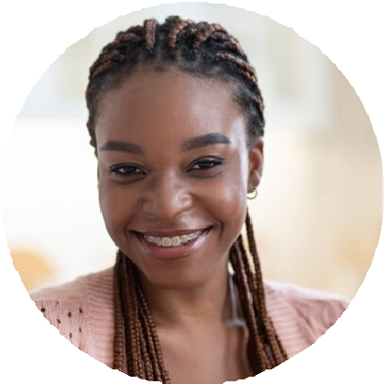
E D U C AT I O N
Bachelor of Fine Arts in Photography
Parsons School of Design, New York, NY | 2016

