Shawn White
Hospitality Social Media Manager

Guest-focused content creator for hospitality brands
Social media manager with 6 years of experience driving bookings and brand loyalty for boutique hotels and hospitality groups. Experienced in destination content, influencer hosting, and seasonal campaigns.

Personal information
Professional experience

(123) 456-7890

email@email.com LinkedIn | Portfolio City, ST 98765

Key skills

Guest experience storytelling Hotel marketing
Destination reels
Trip giveaway promotions Instagram takeovers Property walkthroughs

Social Media Manager | Sunrise Resort Group, Charleston, SC August 2020 - Present

Increased direct bookings by 50% through targeted Reels and influencer content
Built a “Meet the Staff” campaign that improved review engagement by 40%
Partnered with travel influencers to promote fall and spring packages

Marketing Coordinator | Coastal Stay Hotels, Savannah, GA June 2017 - July 2020

Managed Instagram, Facebook, and TripAdvisor responses Created email and social campaigns tied to seasonal specials





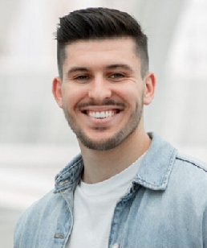

Education

Bachelor of Arts in Hospitality Marketing

University of South Carolina, Columbia, SC | May 2017

