Chris Jackson

Freelance Photographer
Freelance Photographer with seven years of experience capturing lifestyle, editorial, and branded visuals for agencies, startups, and entrepreneurs. Skilled in managing all aspects of production from concept through post-processing.
Deliver consistent results that reflect brand identity and meet fast-paced client timelines.

PERSONAL INFORMATION
PROFESSIONAL EXPERIENCE
FREELANCE PHOTOGRAPHER | NEW YORK, NY FEBRUARY 2018 – PRESENT

(123) 456-7890

email@example.com
Portfolio | LinkedIn City, ST
- Shoot lifestyle and brand campaigns for over 60 clients, delivering edited images within a five-day turnaround
- Provide styling and location recommendations for small businesses, enhancing brand consistency across digital platforms
- Directed and coordinated production for social media campaigns, increasing client content engagement by 40%

KEY SKILLS
STUDIO PHOTOGRAPHER | SPARK CREATIVE STUDIO, NEW YORK, NY JUNE 2016 – JANUARY 2018

- Brand storytelling
- Client relations
- Digital post-production
- Collaborated with stylists and art directors to shoot catalog images for retail clients
- Managed studio lighting setups and optimized image quality for various formats

- Lighting techniques

EDUCATION




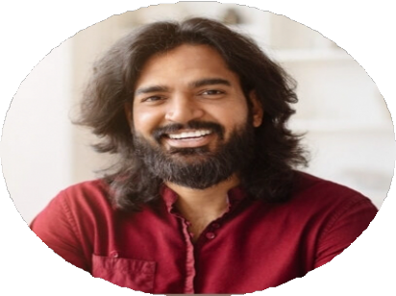
- Photo editing
- Project management
- Bachelor of Fine Arts in Photography, School of Visual Arts, New York, NY | 2016 |

