Personal information

Rebecca
Anderson
Experienced Dental Hygienist
Highly skilled dental hygienist with over 10 years of experience providing top-tier patient care, periodontal therapy, and oral health education. Adept at using advanced dental technology, improving patient compliance with treatment plans, and mentoring junior hygienists.




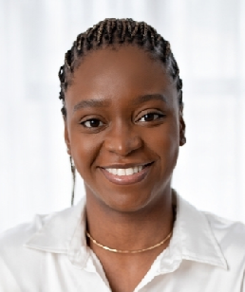
(123) 456-7890

rebecca@example.com Chicago, IL

Education

Bachelor of Science in Dental Hygiene

University of Illinois at Chicago | Chicago, IL | May 2011

Key skills

Periodontal maintenance and therapy
Digital X-rays and charting Laser-assisted hygiene therapy
Patient education and treatment planning
Team leadership and mentoring

Professional experience

Lead Dental Hygienist | Bright Smile Dental | Chicago, IL April 2015 - Present

Conduct thorough dental cleanings and periodontal therapy for an average of 15 patients daily
Train and mentor newly hired dental hygienists and assistants
Implemented an oral health education program that improved patient compliance by 30%

Dental Hygienist | Healthy Smiles Clinic | Naperville, IL June 2011 - March 2015

Provided dental prophylaxis, scaling, and root planing for patients with periodontal disease
Utilized digital radiographs to assist in diagnosis and treatment planning Adhered to strict OSHA sterilization and infection control protocols

Certifications

Registered Dental Hygienist (RDH) – June 2011
Laser Certification for Hygiene Therapy – March 2016 Local Anesthesia Administration – October 2017

