LOGAN HALL
Prosthodontist

ABOUT ME

CONTACT INFORMATION

 (123) 456-7890
 email@example.com  City, ST 12345

KEY SKILLS
- Fixed and Removable Prosthodontics
- Full Mouth Reconstruction
- Implant-Supported Restorations
- Occlusal Analysis
- Smile Design
- Veneer Placement
Prosthodontist skilled in complex restorations and esthetic Dentistry
Board-certified Prosthodontist with over 11 years of experience specializing in full mouth reconstructions, implant-supported restorations, and esthetic prosthetics. Recognized for precision, attention to detail, and patient-focused treatment plans.

PROFESSIONAL EXPERIENCE
Prosthodontist
Elite Dental Restoration Center, Charlotte, NC | June 2016 - Present
  - Completed over 150 full arch rehabilitations using implant-supported prostheses
  - Reduced lab turnaround time by 25% by streamlining digital impression workﬂow
  - Mentored two junior Dentists on esthetic case planning

Associate Prosthodontist
Smile Solutions Group, Raleigh, NC | July 2013 - May 2016
  - Focused on complex restorative cases involving crowns, bridges, and removable partials
  - Increased patient retention by 22% through improved case presentation strategies
  - Led monthly study clubs on occlusal equilibration techniques

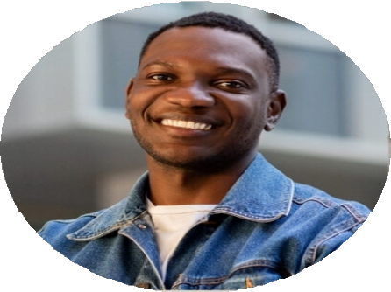
EDUCATION
Doctor of Dental Surgery (DDS)
University of North Carolina | Chapel Hill, NC | May 2013

